Title in Bold and Centered is to Appear in 14 pt. Times New Roman
Using Initial Capitals

Author1^{1*}, Author2¹ and Author3²

¹ Affliation*
*example: WPI-Advanced Institute for Materials Research (WPI-AIMR), Tohoku University
²Affiliation, Address of Author3

These instructions are written in the required style. An abstract should be submitted in a MS word or in a pdf file. Each abstract should consist of one page in A4 size. The length and width of the outline should be 240 mm by 160 mm, respectively. No reduction of the manuscript will be made in the publication if the size is correct.
The title of the abstract should be in 14pt. with a fixed line spacing of 14pt. Leave a line space after the title and then enter the names of the author(s), each followed by a comma and numbers for reference to each author’s affiliation. Leave another one line spaces and then enter the affiliations with full mailing addresses, each on a separate line. Then enter another blank line before the beginning of the text of the abstract.
The rest of the text in the abstract should be in 12pt. Times New Roman typed in a fixed line spacing of 13pt. Do not leave a blank line between each paragraph. Indent to start each paragraph. The text should be justified left and right. The first half of the page contains only text and formulas, while the latter half of the page can contain text, formula’s, tables drawings, graphs micrographs and other figures. Formula’s and special characters can be used, but special care should be taken that these can be properly converted to a PDF.
Figures and tables should be referred to in the text with the proper numbering. All figures and tables should be directly inserted into the file and be accompanied by a caption below the respective figure or above the respective table. Resolutions for figures and graphs between 150 and 600 dpi can be used, but care should be taken that the final abstract file is not larger than 2 MB. Colored figures are allowed but may be reproduced in gray scale.
Place all of the references at the end of the text [1]. List them in sequence of appearance. The references must conform to the following style [2]:

[1] J. Nara, H. Kajiyama, T. Hashizume, Y. Suwa, S. Heike, S. Matsuura, T. Hitosugi, and T. Ohno, Phys. Rev. Lett. 100, 026102 (2008).
[2] N. Fukui, Y. Suwa, H. Yoshida, T. Sugai, S. Heike, M. Fujimori, Y. Terada, T. Hashizume, and H. Shinohara, Phys. Rev. B79, 125402 (2009).
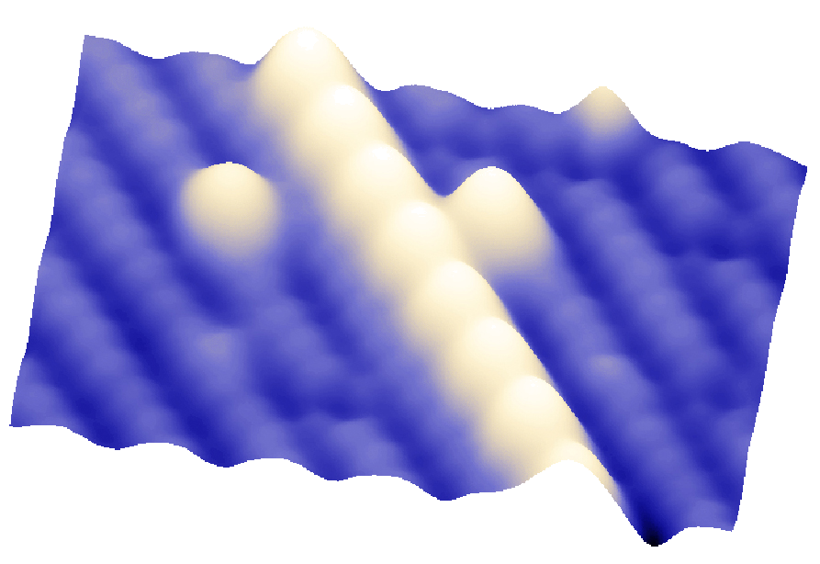

Fig. 1. Color figures can be used but may be printed in gray scale.
*This document should consist of one page in A4 size.

